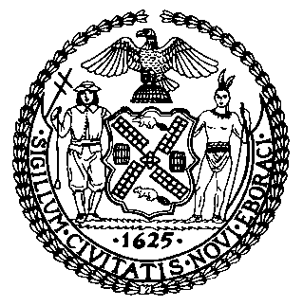 | The Council of the City of New York  Finance Division  Tanisha Edwards, Esq., Chief Financial Officer and Deputy Chief of Staff to the Speaker  Richard lee, director  Fiscal Impact Statement  Preconsidered SLR: S.6246 (Gounardes)  A.6225 (Simon)  Committee: Committee on State and Federal Legislation
Title: An act to amend the vehicle and traffic law, in relation to calibration checks for weigh in motion violation monitoring systems | Sponsor(s): Council Member Abreu
Summary of Legislation: This legislation would requires that each weigh in motion violation monitoring system undergo a calibration check every six months in accordance with specifications prescribed pursuant to a memorandum of agreement between the New York city department of transportation and the New York state department of agriculture and markets, or in accordance with an applicable reference standard as determined by the New York city department of transportation.
Effective Date: This act shall take effect immediately
Fiscal Year In Which Full Fiscal Impact Anticipated: Fiscal Year 2024
Fiscal Impact Statement:
 | Effective FY23 | FY Succeeding  Effective FY24 | Full Fiscal  Impact FY24
Revenues (+) | $0 | $0 | $0
Expenditures (-) | $0 | $0 | $0
Net | $0 | $0 | $0

Impact on Revenues: It is anticipated that there would be no impact on revenues as a result of this legislation.
Impact on Expenditures: It is anticipated that there would be no impact on expenditures resulting from the enactment of this legislation.

Source of Funds To Cover Estimated Costs: N/A

Source of Information: New York City Council Finance Division

Estimate Prepared By: Michael Sherman, Senior Financial Analyst

Estimate Reviewed By: Jack Storey, Unit Head
Chima Obichere, Deputy Director

Legislative History: This bill will be considered by the Committee on State and Federal Legislation as a Preconsidered SLR on May 25, 2023. Following a successful vote by the Committee, the Preconsidered SLR will be introduced and voted on by the full Council on May 25, 2023.
Date Prepared: May 24, 2023

